EARLY WARNING BULLETIN FOR FOOD SECURITY

No. 2014/04 IN THE GAMBIA Period: June 1 – 10, 2014

 Government of The Gambia | Produced and Published by The Gambia National Multidisciplinary Working Group  Focal Point: Department of Water Resources  TEL: (+220) 4227631 / 4224122 / 8905229 - FAX: (+220) 422 50 09  E-MAIL: dwr@mofwrnam.gov.gm  WEB: www.mofwrnam.gov.gm | Gambian flag

- METEOROLOGICAL SITUATION

1.1 GENERAL SYNOPTIC SITUATION:

The average surface position of the ITD during this, dekad was over central Senegambia , stretching towards southern Mali and Niger and onto Chad. Places to the north of the ITD were dry and stable with dust haze/sand storm reported over southern Algeria, Mauritania and northern Mali. On the other hand, to the south of the ITD the weather was dominated by convective cloud development leading to outbreaks of thunderstorms with rain over Guinea Conakry, Ghana, Togo, Burkina Faso and Nigeria.

1.2 WEATHER SUMMARY FOR THE GAMBIA

Partly cloudy to cloudy conditions, warm and humid weather with widespread thunderstorms accompanied by strong winds were experience across the country during the early part of the dekad.

2.0 AGROMETEOROLOGICAL SITUATION

2.1 RAINFALL SITUATION

The rainy season is in progress in almost in all the Regions across the country. Sowing of some cereals crops notably early millet, however most farmers are still busy on preparing their fields for sowing. Rainfall was recorded in all the Regions during this dekad. In the Eastern Third Basse recorded the highest with a dekadal total of 50.6mm followed by Fatoto recording 32.6mm. In the Middle Third, Jenoi recorded the highest with a dekadal total of 20.1mm followed by Sapu recording 16.4mm, Janjanbureh 13.5mm and Kaur recorded the least of 6.7mm. In the Western Third, Yundum recorded the highest of 24.8mm followed by Sibanor recording 17.5mm. (Figure 1a).

For Seasonal totals the Eastern Third has the highest record, with Fatoto and Basse recording 95.3 and 76.5mm respectively. In the Middle Third Sapu has the highest 33.0mm and the least was recorded at Kaur of 6.7mm. In the Western Third Yundum recorded the highest of 27.8mm, while Kerewan does not still record any measurable rainfall (Figure 1b).

Figure 1a: Dekadal rainfall totals (mm) for 1st to 10th June 2014

Figure 1b: Seasonal rainfall totals (mm) for 1st May to 10th June 10 2014

2.2 Thermal situation

Average temperatures across the country varied between 31.0ºC in the Eastern Third, 30.0ºC in the Middle Third, and 28.0ºC in the Western Third. Highest temperatures were 46.0ºC in the Middle Third and 40 ºC in the Western and Eastern Thirds. Minimum temperatures have rose significantly to 28.0ºC in Middle and Eastern Thirds to 26.0°C in the Western Third.
.
2.3 Winds

There were some gusty winds during this dekad ranging from 55km/h in the Western Third, 64km/h in the Middle Third to 74km/h in the Eastern Third. There were some structural damages especially in Jenoi in the Middle third where some fences fell.

2.4 Sunshine Duration

Sunshine duration varied from 6.4 hours in the Eastern Third to 8.7 hours in the Middle Third.

2.5 Relative Humidity

Average maximum relative humidity (RH) was 67% in Western Third, 65% in the Middle Third and 71% in the Eastern Third of the country.

3.0 Hydrological Situation
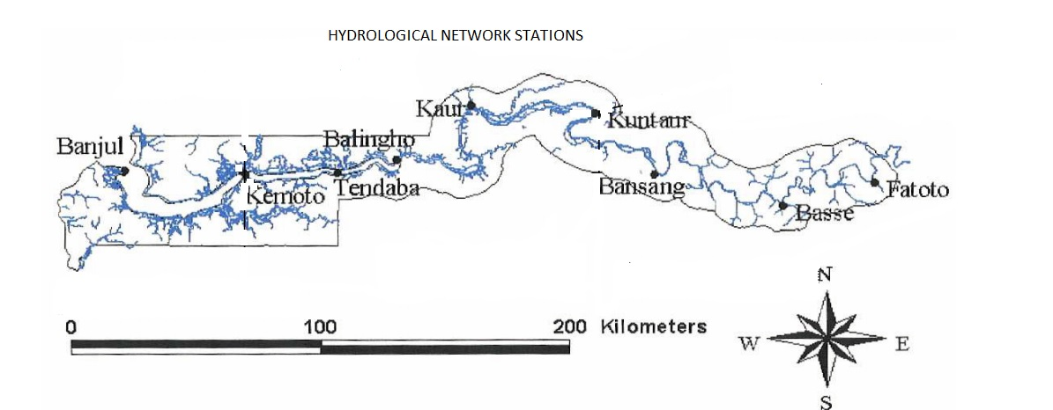
Figure 2: Hydrological network

The hydrological situation of the country at recent moment is at a stage of rehabilitation and hence not in a position to provide adequate data, only Bansang that operates and is not fully operational.

Meanwhile, with support from the National Water Sector Reform Project (NWSRP), work is currently going on towards the operationalization of three network stations (Banjul Wharf, Pakaliba and Bansang) with up to date hydrological equipment.

Discharge measurement that is been conducted at Dampha Kunda (Basse) has not started, although the area has received some rains but there is no visible and continued flow in the stream.

4.0 AGRICULTURAL SITUATION

The dominant on-field activities by farmers continued to be field clearing, acquisition and preparation of seeds. Meanwhile, some farmers had already began sowing of early millet. This activity is believed to be wide spread across its growing areas, although not at a large scale.

Composition of MWG:  Department of Water Resources  Planning Services - Department of Agriculture (DOA)  Communication, Extension & Education Services - DOA  Animal Health & Production Services - DOA  Plant Protection Services - DOA  National Environment Agency | Direct your comments and questions to:  The Director  Department of Water Resources  7 Marina Parade, Banjul  The Gambia  Tel: (+ 220) 422 76 31 / 422 41 22 / 890 52 29  Email: dwr@mofwrnam.gov.gm

